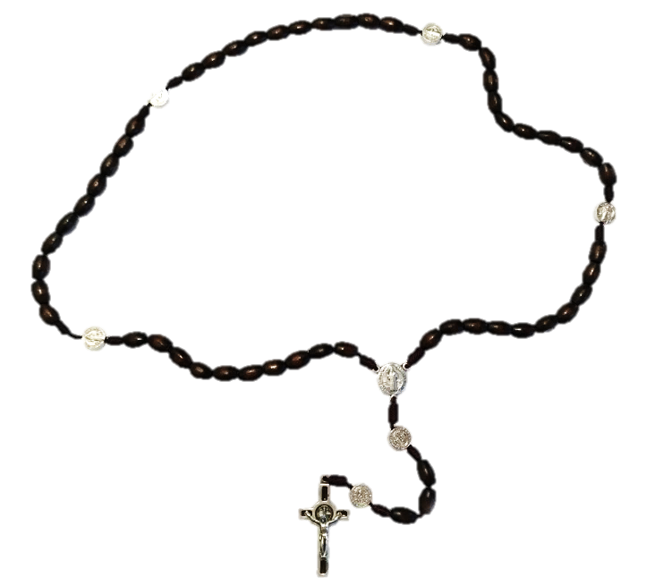

"The Rosary is the weapon for these times." St. Padre Pio

Rosary around Switzerland

Pray for Switzerland and the world
Sunday, 1 October 2023

in Catholic Churches and Chapels throughout Switzerland
(with Papal and Episcopal blessings)

Participate in the prayer event
The organization Pray Schwiiz! cordially invites you to join others and pray on this day for our country and its people, for all peoples of the world and for Holy Mother Church. We entrust our prayers to the Blessed Mother who will take them to her Son Jesus as only a Mother can. At www.prayschwiiz.ch you can find the nearest prayer location, what you can expect on the day of prayer and many other useful items.

Organize a place of prayer
Don’t see a prayer site near you? We would strongly encourage you to organize a place of prayer yourself. It is simple: find an appropriate location, get the proper permissions and then coordinate with the priest who will lead the prayer service. Next contact Pray Schwiiz! so your location can be registered and published on the website for all to see.

For more info: www.prayschwiiz.ch and www.facebook.com/RosaryaroundSwitzerland
Mail: prayschwiiz@gmail.com Tel: 076 746 00 68

God bless you for your interest and commitment!

